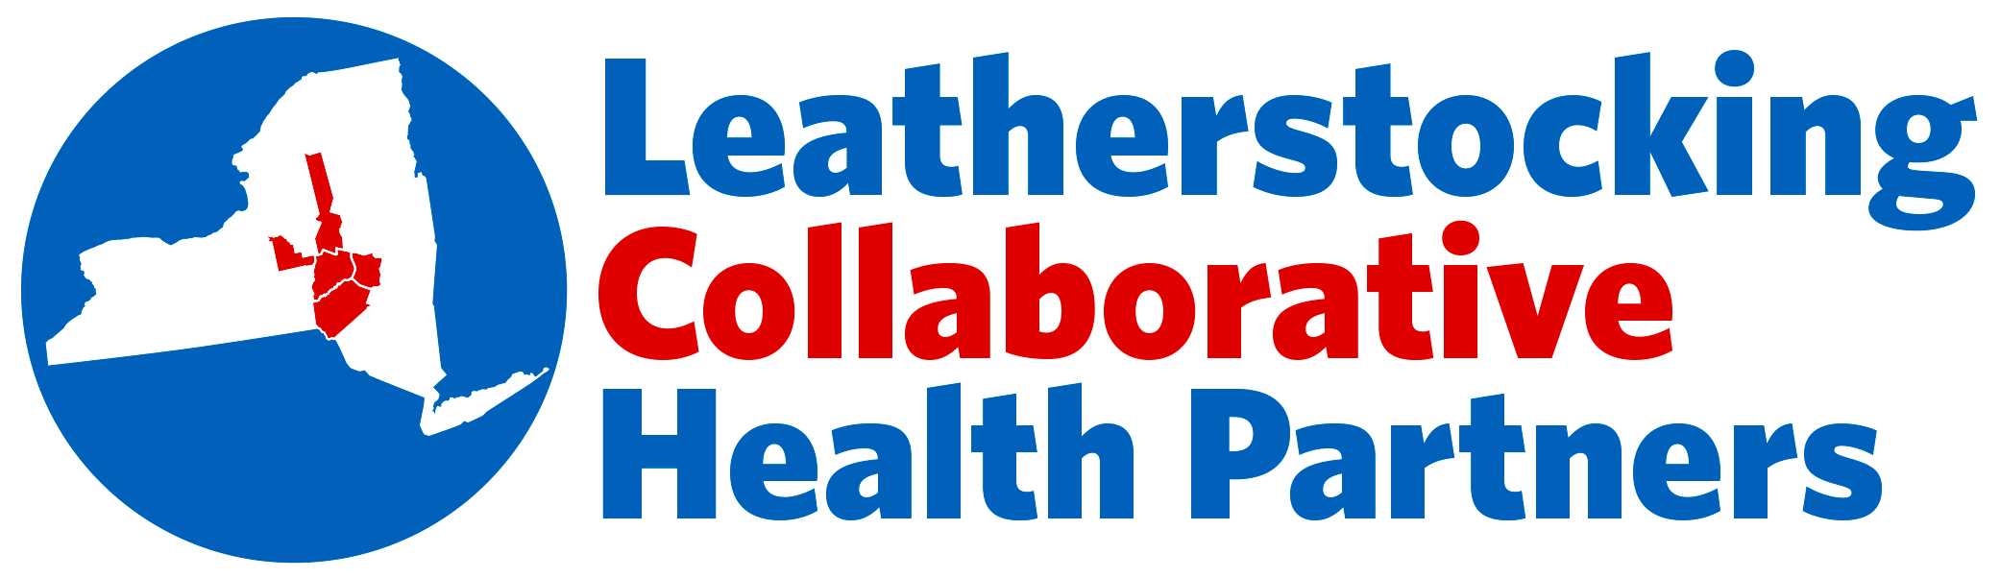 cid:image001.gif@01CFF39C.CF8B3BD0

**SAVE THE DATE!**

**The Office of Medical Education and Leatherstocking Collaborative Health Partners**

**will be holding a workshop on:**

**Confronting Disparities of Care:**

**An Evening of Practitioner Cultural Competency**

**Wednesday, November 30, 2016**

**4:30-8:30pm**

**The Otesaga Resort Hotel**

Registration will start at 4:00 pm

Workshop Topics: Cultural Competency for LGBTQ Patient Population

Overcoming Disparities for Opioid Addicted Patients

Eldercare Disparities

Dinner & Keynote Presentation: Cultural Competency for Opioid Addicted Patient Population

Panel Discussion: Providers & Caregivers as the Minority – Reverse Disparities of Care

**Limited Seating Available – First Come, First Served**

**To Register free of charge:**

[**kara.travis@bassett.org**](mailto:kara.travis@bassett.org)

[**kathy.waro@bassett.org**](mailto:kathy.waro@bassett.org)