- The NYSARH Site on HWapps:

- Navigate to site: http://www.hwapps.org/newyork/nysarh/ once your HWapps account has been created.
- Upon your first visit to the site, you have the option to ‘favorite’ the NYSARH page which will make it easier for future access. To do this, click the plus (+) icon (red arrow in Figure 1) to favorite the page. To access this page in the future, simply click the gold star in the upper-right corner (blue arrow in Figure 1).

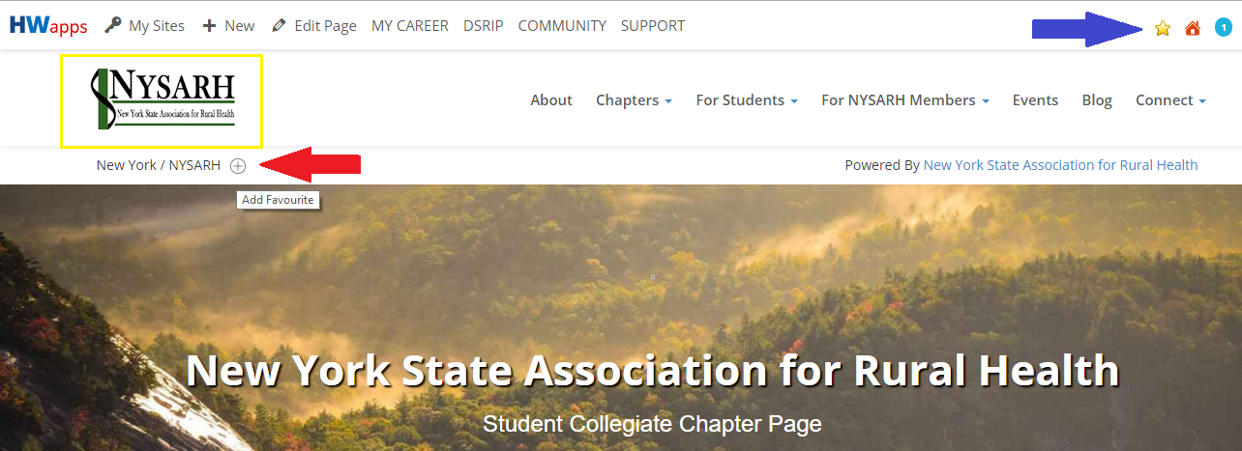
Figure 1

- While on the NYSARH site, if a member wishes at any point to return to the NYSARH home page on HWapps (i.e. the page represented in Figure 1), simply click the NYSARH logo in the top-left corner (yellow box).

- Starting with the menu at the top, view the About page and the Chapters drop-down list. Clicking on the specific Student Chapters will bring the member to the specific Student Chapter Community groups*. In addition, the Chapter Map is an interactive map showing of current NYSARH student chapters.

- For Students:
  - Explore Health Careers links to a page with various career exploration resources, including My Health Career, a Skills Profiler, and the HWapps community (will be explained in greater detail later).
  - Find Internship Opportunities links to a job and internship board where students can view available openings
  - Post Your Resume links to a resume board where students can post their resumes for NYSARH members, professionals, and fellow students to view and network.
  - Find Continuing Education is an opportunity for students to view available resources to further develop their healthcare education
  - Community-Based Programs/Projects links to a listing of Programs that is site-wide on HWapps and includes various job-shadowing, employment, program opportunities state-wide hosted by various different networks and organizations
  - Join a Student Chapter is a tool for students who do not currently belong to a student chapter at their higher education institution, but would like to start one. Starting a NYSARH Student Collegiate Chapter is made easy by this short Membership Request.

- For NYSARH Members:
  - Connect with Students is a direct link to NYSARH’s Community group* page, which is the single most effective way to communicate with not only all members of the Student Chapters, but with all other NYSARH Members who are a part of the group. Listed on the right-hand side of the group’s page are various “sub-groups”, or the various NYSARH Student Chapter community groups. NYSARH members are encouraged to also request membership to Student Chapter groups to maximize the opportunity of connecting with students.
  - Search Student Resumes is a link to a resume board where NYSARH members can easily search and view resumes posted by Student Chapter members for networking opportunities.
  - Post a Job/Internship is a link to a job and internship board where NYSARH members can post opportunities for student chapter members. It is an effective way to fill open positions and provide student chapter members with excellent opportunity for professional development.
  - Clicking on Add a Community-Based Program, Add an Event, Add a Continuing Education Opportunity, and Write a Blog Post will all prompt a Request Content Submission Form that, when filled out, will be generated into displayable content designed in the most effective way possible for students to see.

- View the Events link to search a listing of upcoming Events that are posted through the feature described in 6.d.

- The Blog page operates like an internet forum. Any member or student can start a thread (a series of messages that represent a continuous chain of replies and dialogue), or a forum post, as brief or substantial as they want, so that other members and students can both read and engage in discussion. When blog posts are subscribed to, members will receive email updates when other members contributed to the thread.

- Connect directly links to the NYSARH Community group* that was mentioned on line 6.a.

- The Search bar in the middle of the page may become useful for a member or student to search a specific program or opportunity on the site.

- Scrolling down, there are three tools specifically geared towards Student Chapter Members (see Figure 2). These three features re-organize resources found in the For Students drop-down menu found on line 5 of this guide. Specifically, the re-organization offers students a more conceptual, intuitive guide starting with Career exploration and ending with Professional development.
  - Getting Started provides the same Career Exploration Resources found in the For Students drop-down option found mentioned on line 5.a.
  - Exploring Opportunities provides the Community-based Programs mentioned in the For Students drop-down option found mentioned on line 5.e.
  - Continuing Education provides students with the Continuing Education course listings mentioned in the For Students drop-down option found mentioned on line 5.d.

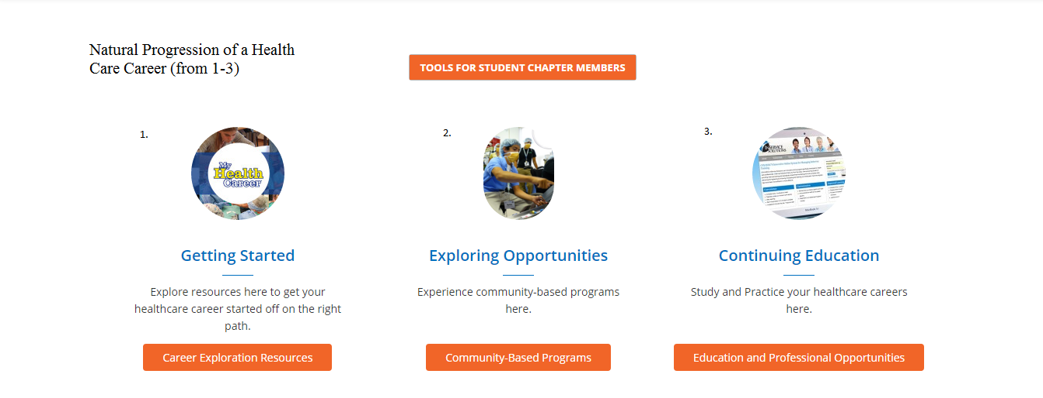

Figure 2

II. NYSARH Community groups in the Community
- * Community Groups are groups different from, and on a separate area of the site as, the NYSARH page discussed in part I. of this guide. There are two Community groups currently associated with NYSARH: the NYSARH community group, or the “parent group”, and the SUNY Potsdam Student Chapter group, or the “sub-group”.SUNY Potsdam student members will be members of both groups, but NYSARH members will only be members of the NYSARH group. The logic behind this is:
  - First and foremost, this is the single-most effective way for NYSARH members and students to communicate with each other, spread information, events, and anything that goes beyond what is covered by the features discussed in this guide.
  - This engagement between NYSARH members and students is best conducted in the NYSARH group, of which both parties are a part of and any member on HWapps can join.
  - The individual Student Chapter Community groups are currently private for the reason that they will be used for administrative and internal affairs such as minutes-posting, official document posting, event scheduling, and easy inter-member communication.

- Accessing the Community groups can be done through one of the following ways:
  - From the NYSARH page, by selecting Connect with Students from the For NYSARH members menu drop-down. This will bring you to the NYSARH member group (both students and NYSARH members).
  - From the NYSARH members group page, individual Student Chapter groups can be accessed by clicking on them on the right-side of the page.
  - Once you are a member, you can easily navigate to the Community by clicking on the link at the top of the HWapps page. Once there, members can view the groups they are a part of by clicking My Groups (red arrow in Figure 3).
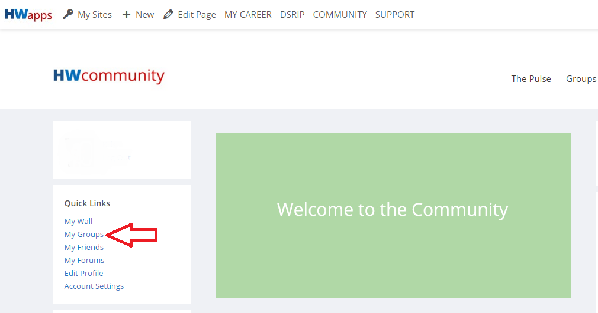

Figure 3

