LMS Training & Courses – Things to Remember

Overview
You will use HWapps’ LMS tool to upload your DSRIP trainings. These courses will go into the CCN Training Center which is accessed in the top menu by selecting Trainings & Courses from DSRIP Trainings. Courses are either “Live” or “Online”. To access the page where you begin adding a course, select Admin Center from For CCN Admins in the top menu. From the CCN Admin Center page, select Add Training.

Live Courses
Posting a Live course is effectively like advertising an event: you are promoting the course’s date, location, target audience, and nature. HWapps’ registration tool acts as an online sign-up sheet and will collect all of the necessary DSRIP workforce information. For Live courses, you only need to create the “course shell”. In other words, creating lessons and quizzes is not necessary.

Online Course
Online courses are more complex than Live courses and use more of the LMS tool. Generally, most courses will have a lesson and a quiz. It is important to understand that “quiz” is misleading because the “quiz” tool can be used for any number of things. Primarily, the “quiz” tool gets used for including Attestation Statements at the end of an online course. The “lesson” is where the actual course content is published. Creating an online course with a lesson and a quiz requires three steps: creating the course (the shell), then creating the lesson (the content), and then creating a quiz.

For online courses, it is mandatory for participants to register an account when they register for the course. This is done automatically. The only way to track participation in online courses is to ensure that participants are logged into their registered accounts.

Required Items when Adding a Course
When creating a course, to ensure the course has the proper settings and gets posted in the correct location on HWapps, please ensure you have completed all mandatory steps. The following tables outline which items are mandatory when adding a course. All items are found on an Add course page, which is the page used when uploading an LMS course (select Add a Training in the CCN Admin Center to access this page).

Course Form - Required Items

Course Details  Figure 1 | Select “Live” or “In person” whenever asked.  [Live courses] If your live course has multiple sessions, then you need to list each date & time in the ‘Date & Time’ field: adding a row will open up a new field to add a session in.  [Online Course] For online courses, only ‘Training Date’ is mandatory.
Registration  Figure 1 | “Registration Close Date” is optional, yet the date you enter here will be the date that registration closes for the course.  Always, in all circumstances, ensure that “Use HWapps Registration Tool” is selected. If it is not selected, you will NOT be able to track any participant information.  [Live Courses] For Live courses, it is not required to have an account created when a user registers since participants do not need an HWapps account to participate in a Live training. You may choose to have “Get User registered?” unchecked.  [Online Courses] You ALWAYS need to ensure “Get User registered?” is selected because participants cannot take an LMS training without an account.

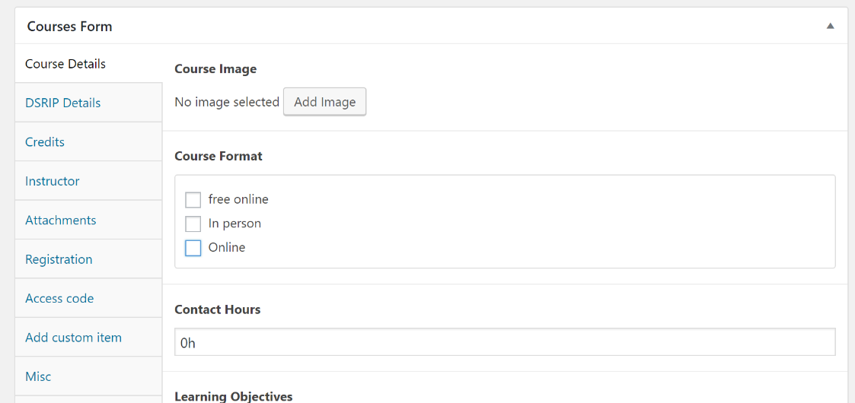

Figure 1

Additional – Required Items

Course Price Type  Figure 2 | This is the ONLY mandatory field in the ‘Course’ Section at the bottom. Always ensure you have selected ‘Free’ and not ‘Open’. Free is the only price type that will ensure that the HWapps Registration form gets used to track DSRIP information.
Courses PPS Section & Partner Organization  Figure 3 | On the right-hand side of the page, it is required that you select the PPS the course belongs to. Without doing so, the course will not be posted anywhere.  You then need to permit the respective POs to have access to the course; select from the list the POs of which pertain to the course. In the instant that the course is open to all of your POS, use the “select all” option.  If you are asked to select PPS or PO anywhere else, ensure you do so.

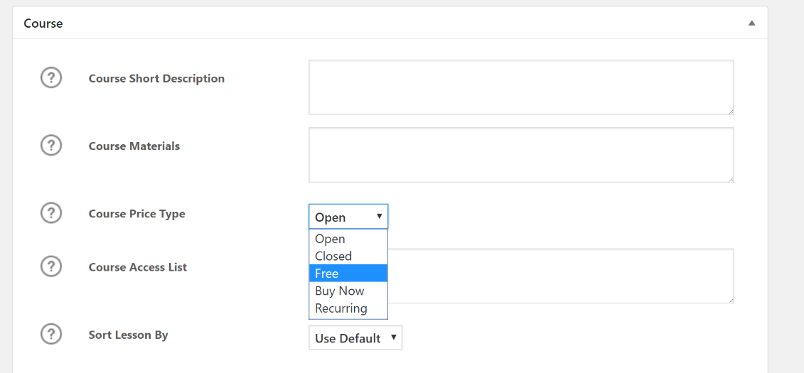

Figure 2

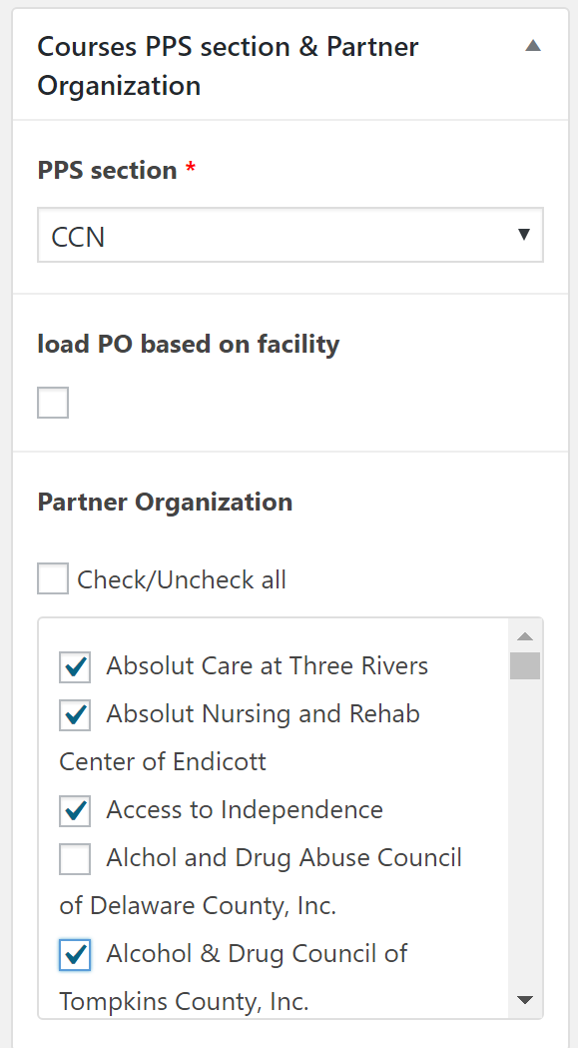

Figure 3

